**HOL P100 - Creating a Padarn Web Solution**

# Table of Contents

Table of Contents 2

HOL Requirements 3

Summary 4

Lab Objective 4

Exercise 1: Creating the Padarn Solution and Server Hosting Project 6

Exercise 2: Creating the Code-Behind Library Project 10

Exercise 3: Creating the Static Content Project 13

Exercise 4: Adjust the Solution Configuration Options 17

Exercise 5: Setting the Project Deployment Directories 20

Hands-on Lab Summary 25

# HOL Requirements

The following items are required to run this HOL:

* A Desktop PC running Microsoft Windows® XP or Windows Vista
* Microsoft Visual Studio 2008 Professional (or higher)
* A Web Browser
* A Padarn reference system or developer kit

While Padarn will run on almost any hardware that supports the Microsoft .NET Compact Framework 2.0 or higher, this lab assumes that you have one of the Padarn reference hardware platforms with an OpenNETCF-validated Windows CE image running on it. If you are using an alternate hardware or software configuration, the steps outlined in this Hands-on Lab may not be accurate for your environment.

# Summary

In this lab, you will learn how to create a Visual Studio 2008 Solution for developing and testing a web site running on the OpenNETCF Padarn Web Server for Windows CE. While no code will be written during this lab careful attention to all steps in the lab are very important as the resulting Solution will greatly simplify deployment and debugging of your site during the development process.

# Lab Objective

Upon completion of this lab, you will be able to create a Visual Studio 2008 Solution containing all of the necessary Projects to easily develop, deploy and debug a full Padarn web solution.

In this HOL, you will perform the following exercises:

* Create a Smart Device Solution containing all necessary projects for a Padarn Solution
* Adjust the Solution Configuration options to ensure correct build and deployment behavior
* Set the Project Deployment Directories for each Project

## Exercise 1: Creating the Padarn Solution and Server Hosting Project

In this exercise, you will use Visual Studio to create a Padarn solution containing several different projects, each with a specialized purpose. This solution will be the basis project for future exercises in this and other Padarn labs.

To create the Solution and the Server Hosting Project:

1. Open Microsoft Visual Studio 2008
2. In Visual Studio, click on the **File** menuand then **New**, and select **Project**
3. In the **New Project** dialog box, under **Project Types**, expand **Visual C#,** and select the **Smart Device** project type.
4. Under **Visual Studio installed templates**, select **Smart** **Device Project**
5. In the **Name** text box, type **ocfhttpd** (short for ‘*OpenNETCF Hypertext Transfer Protocol Daemon*’)
6. In the **Solution Name** text box, type **MyPadarnSolution**.
7. In the **Location** text box, enter the path where you would like Visual Studio to create your Solution and Project files.
8. Click **OK** to move on to the **Add New Smart Device Project** Wizard

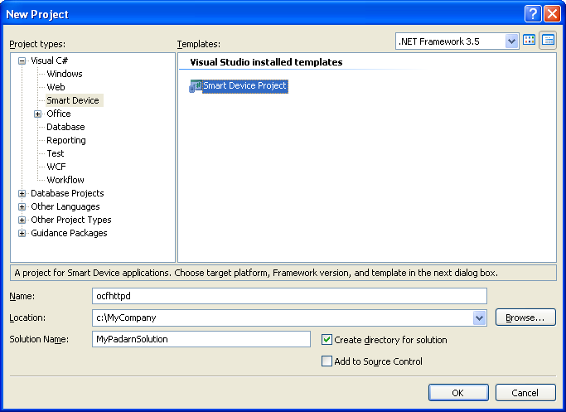

In the **Add New Smart Device Project** Wizard:

1. Select **Windows CE** from the **Target platform** dropdown.
2. Select **.NET Compact Framework Version 2.0** from the **.NET Compact Framework version** dropdown.
3. Select **Device Application** from the **Templates** list
4. Click **OK** to have the Wizard generate the Solution and your initial Project.

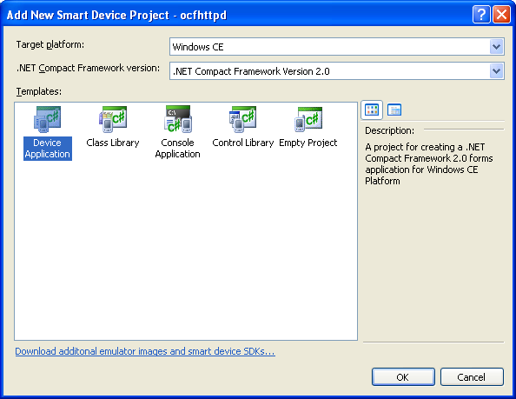

1. In Visual Studio’s **Solution Explorer** pane, ensure that **Solution ‘MyPadarnPadarnSolution’** is selected.

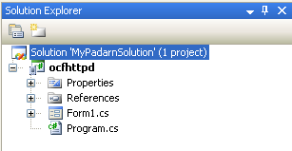

1. From the Visual Studio **Project** menu item, select **Add New Solution Folder** and name the new folder **Server Host**.

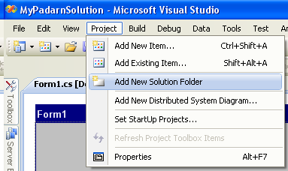

1. In Visual Studio’s **Solution Explorer** pane, drag the **ocfhttpd** Project into the newly created **Server Host** Solution Folder.

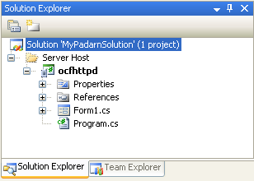

## Exercise 2: Creating the Code-Behind Library Project

In this exercise, you will use Visual Studio to create the project that will generate the assembly containing all of your web page code-behind classes.

To create the code-behind Project:

1. From the Visual Studio **Project** menu item, select **Add New Solution Folder** and name the new folder **Code Behind**.

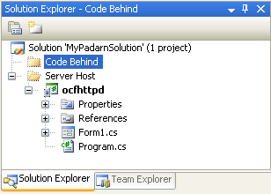

1. In Visual Studio’s **Solution Explorer** pane, select the **Code Behind** Solution Folder.
2. In Visual Studio’s **File** menu, select **Add** and then **New Project…** to launch the New Project Wizard.
3. In the **New Project** dialog box, under **Project Types**, expand **Visual C#,** and select the **Smart Device** project type.
4. Under **Visual Studio installed templates**, select **Smart** **Device Project**
5. In the **Name** text box, type **MyPageLibrary**.
6. Click **OK** to move on to the **Add New Smart Device Project** Wizard

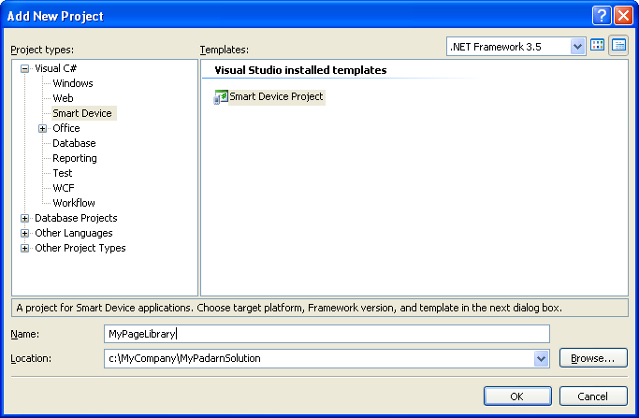

In the **Add New Smart Device Project** Wizard:

1. Select **Windows CE** from the **Target platform** dropdown.
2. Select **.NET Compact Framework Version 2.0** from the **.NET Compact Framework version** dropdown.
3. Select **Class Library** from the **Templates** list
4. Click **OK** to have the Wizard generate your code-behind library Project.

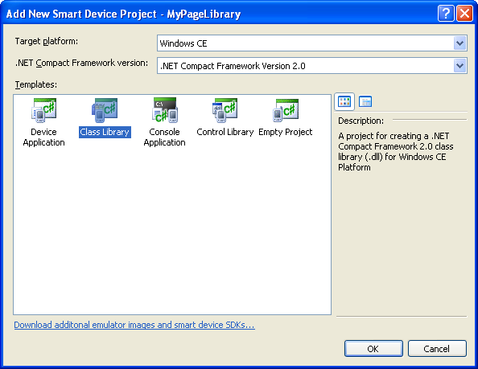

1. In the **Solution Explorer** pane, select the default **Class1.cs** file and delete it from the project.

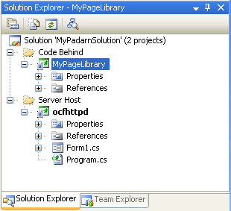

## Exercise 3: Creating the Static Content Project

In this exercise, you will use Visual Studio to create the project that will be used to hold and organize all of your web site’s static content (HTML pages, images, style-sheets, etc). This project *will not* contain any code for compilation.

To create the static content Project:

1. From the Visual Studio **Project** menu item, select **Add New Solution Folder** and name the new folder **Static Content**.

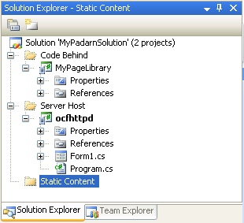

1. In Visual Studio’s **Solution Explorer** pane, select the **Static Content** Solution Folder.
2. In Visual Studio’s **File** menu, select **Add** and then **New Project…** to launch the New Project Wizard.
3. In the **New Project** dialog box, under **Project Types**, expand **Visual C#,** and select the **Smart Device** project type.
4. Under **Visual Studio installed templates**, select **Smart** **Device Project**
5. In the **Name** text box, type **StaticContent**.
6. Click **OK** to move on to the **Add New Smart Device Project** Wizard

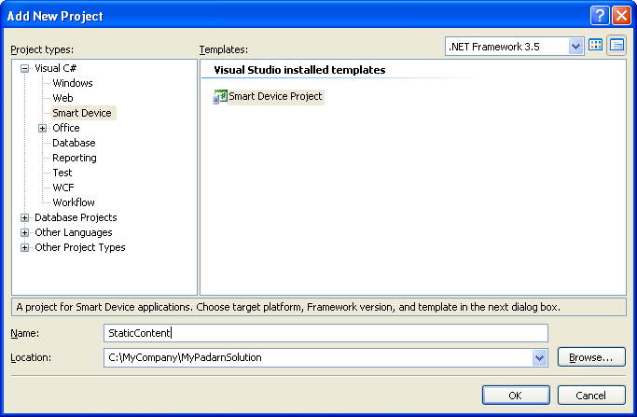

In the **Add New Smart Device Project** Wizard:

1. Select **Windows CE** from the **Target platform** dropdown.
2. Select **.NET Compact Framework Version 2.0** from the **.NET Compact Framework version** dropdown.
3. Select **Empty Project** from the **Templates** list
4. Click **OK** to have the Wizard generate your code-behind library Project.

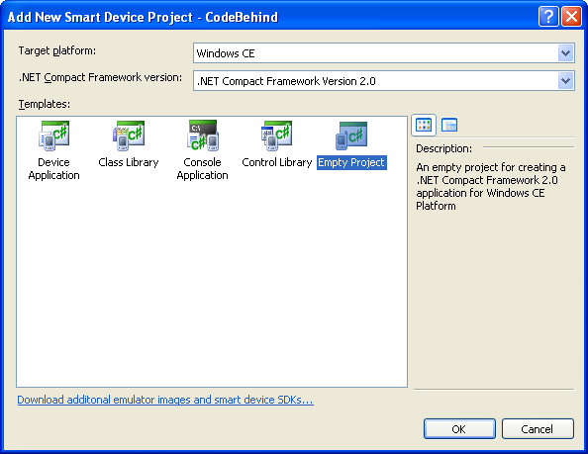

1. In the **Solution Explorer** pane, right-click on the **StaticContent** Project, select **Add -> New Folder** and name the new folder **Inetpub**. This is the folder that will contain the ASPX files that you create in later labs.

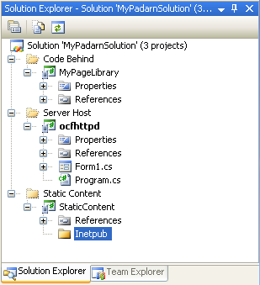

1. In Visual Studio’s **Solution Explorer** Pane, right-click on the **StaticContent** project and select **Properties** to display the **StaticContent Project Properties** dialog.
2. From the **Output type** drop-down, select **Class Library**.

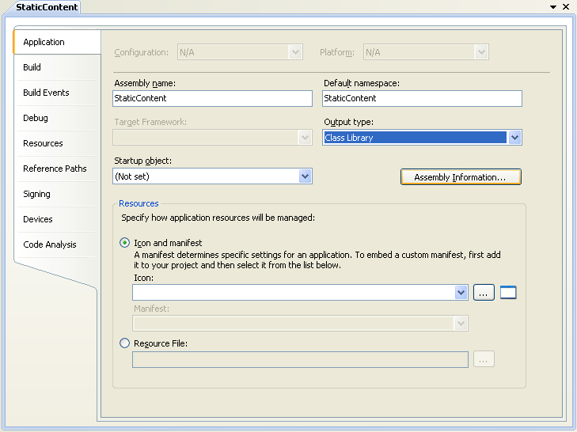

1. From the menu in Visual Studio select **File -> Save**.

## Exercise 4: Adjust the Solution Configuration Options

In this exercise you will configure the Solution’s Configuration Options to ensure the all Projects have the correct Build and Deploy settings to help ensure that the process of deployment and debugging will be simple and seamless.

1. In Visual Studio’s **Solution Explorer** pane, ensure that **Solution ‘MyPadarnPadarnSolution’** is selected.

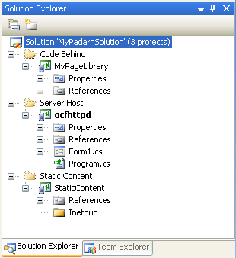

1. From the Visual Studio **Project** menu item, select **Properties** to display the **Property Pages** dialog for the **MyPadarnSolution** Solution.

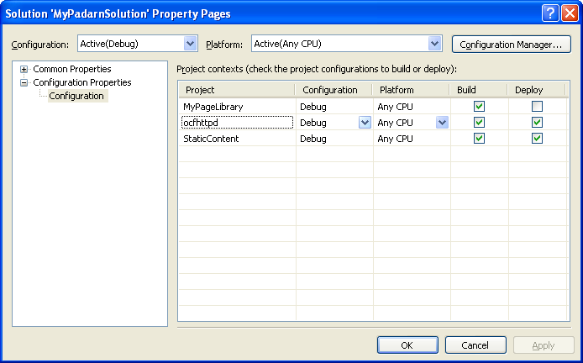

1. From the **Configurations** dropdown, select **All Configurations**.
2. Check the **Deploy** checkbox for the **MyPageLibrary** Project.

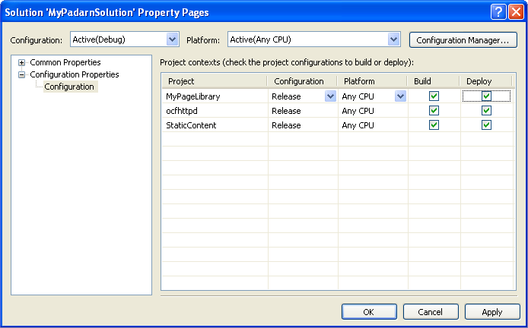

1. Click **OK** to save your changes and close the **Property Pages** dialog.

When the **StaticContent** project is built, it will generate a DLL, **StaticContent.dll**, and a debug symbol database, **StaticContent.pdb**. Padarn does not require these files so you will need to specific a **build event** to quietly delete them when the build is successful.

1. In Visual Studio’s **Solution Explorer** pane, select the **StaticContent** Project.
2. From the Visual Studio **Project** menu item, select **Properties** to display the **StaticContent** Project Properties tab and select the **Build Events** group.
3. Click in the **Post-build event command-line** textbox and type the following:  
     
   del /q $(TargetDir)$(TargetName).*  
     
   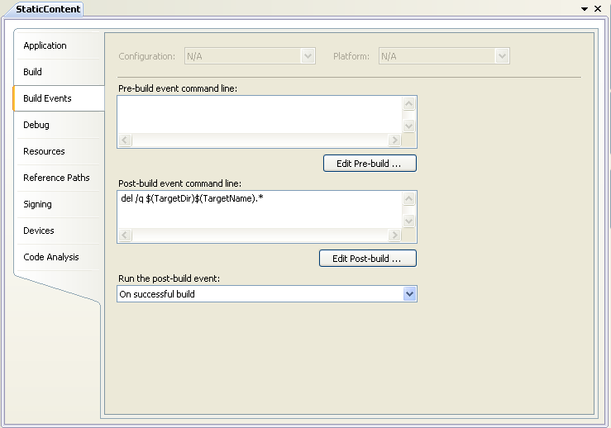
4. Close the **StaticContent** Project Properties.

## Exercise 5: Setting the Project Deployment Directories

In this exercise you will configure the Projects’ Device Output File Folders to ensure that all projects deploy to a common location on your target device.

1. In Visual Studio’s **Solution Explorer** pane, select the **StaticContent** Project.

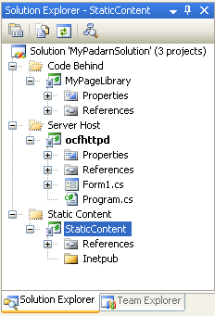

1. From the Visual Studio **Project** menu item, select **Properties** to display the **StaticContent** Project Properties tab and select the **Devices** group.

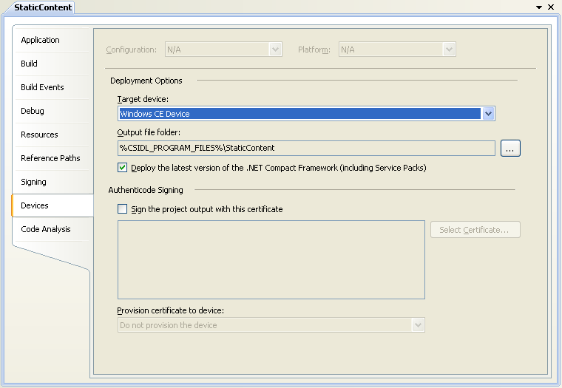

1. Click on the **[…]** browse button to the right of the **Output file folder** text box to display the **Output File Folder** dialog.
2. Change the **Location of output on Device** dropdown to **Root Folder**.
3. Change the text in the **Subdirectory** text box to **Padarn**.

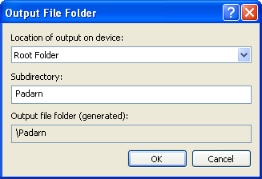

1. Click **OK** to save your changes and close the **Output File Folder** dialog.
2. In Visual Studio’s **Solution Explorer** pane, select the **MyPageLibrary** Project.

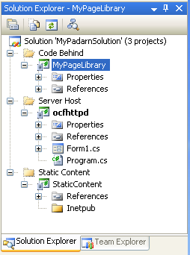

1. From the Visual Studio **Project** menu item, select **Properties** to display the **StaticContent** Project Properties tab and select the **Devices** group.

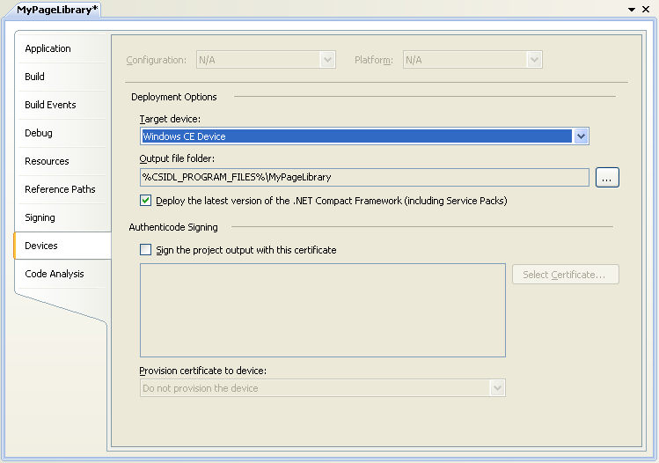

1. Click on the **[…]** browse button to the right of the **Output file folder** text box to display the **Output File Folder** dialog.
2. Change the **Location of output on Device** dropdown to **Root Folder**.
3. Change the text in the **Subdirectory** text box to **Padarn\Inetpub\bin**.

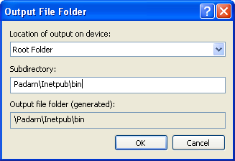

1. Click **OK** to save your changes and close the **Output File Folder** dialog.
2. In Visual Studio’s **Solution Explorer** pane, select the **ocfhttpd** Project.

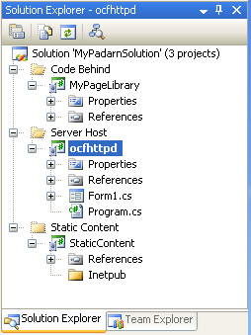

1. From the Visual Studio **Project** menu item, select **Properties** to display the **ocfhttpd** Project Properties tab and select the **Devices** group.

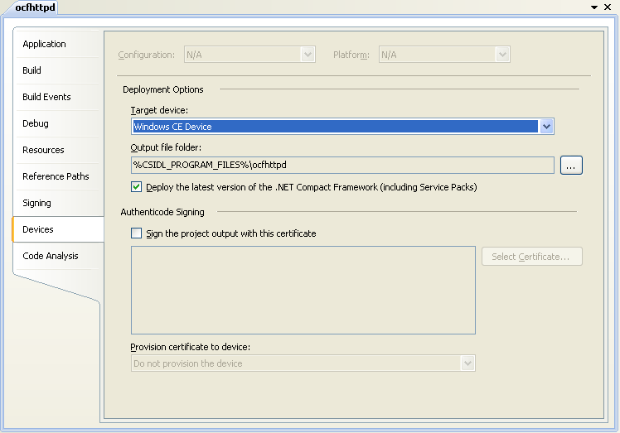

1. Click on the **[…]** browse button to the right of the **Output file folder** text box to display the **Output File Folder** dialog.
2. Change the **Location of output on Device** dropdown to **Root Folder**.
3. Delete all text in the **Subdirectory** text box.

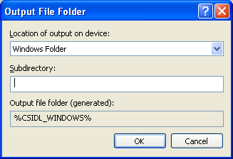

1. Click **OK** to save your changes and close the **Output File Folder** dialog.

# Hands-on Lab Summary

While no code was written during this lab, you performed the very important step of setting up your Padarn solution.

In this lab you:

* Created your Padarn Web Site solution
* Created separate projects for the server host, static content and the code-behind classes.
* Adjusted the Solution Configuration options to ensure correct build and deployment behavior
* Set the Project Deployment Directories for each Project

Using these steps as a guideline for Padarn projects will greatly simplify deployment and debugging of your site during the development process.